ASSIGNMENT NO. 3
Dimensionality Reduction using PCA

Aim
To cut down the number of features in a dataset with Principal Component Analysis (PCA) while keeping as much of the information as possible.

Objectives
- Understand why too many features cause problems.
- Learn how PCA builds new features called principal components.
- Find how many components keep 95% of the variance.
- Check whether a model still performs well on the reduced data.

Software and tools
Python 3, written and run in Jupyter Notebook (VS Code works too) on Windows. Libraries used: numpy, matplotlib and scikit-learn.

Theory

1. The trouble with too many features
Real datasets often have dozens or hundreds of columns. With that many, models train slowly and use more memory. They're also more likely to overfit, which means learning noise instead of the real pattern. And we can't plot the data, because we can only see two or three dimensions. People call this the curse of dimensionality.

2. Reducing dimensions
There are two ways to bring the column count down. Feature selection keeps some of the original columns and drops the rest. Feature extraction builds a smaller set of new columns, each one a mix of the old ones. PCA is feature extraction.

3. How PCA works
PCA looks for the direction in which the data is most spread out. That direction is the first principal component, PC1. PC2 is the direction with the next most spread, at a right angle to PC1, and so on. Most of the spread usually sits in the first few components, so we keep those and drop the rest.
It's a bit like photographing a 3D object. From the right angle, a flat photo still shows almost everything that matters. PCA finds that angle for our data.

4. Steps of PCA
- Standardise the data so every column has mean 0 and standard deviation 1.
- Work out the covariance matrix, which shows how the columns vary together.
- Find the eigenvalues and eigenvectors of the covariance matrix.
- Sort the eigenvectors by eigenvalue, largest first.
- Keep the top k eigenvectors. These are the principal components.
- Multiply the original data by these eigenvectors to get the new, smaller dataset.

5. Explained variance
Each eigenvalue says how much of the total variance its component holds. One component's share is:
Explained Variance Ratio of PCᵢ = λᵢ / (λ₁ + λ₂ + … + λₙ)
Adding these shares up one by one tells us how many components we need, for example enough to reach 95%.

6. Advantages and disadvantages
Advantages | Disadvantages
Models train faster | The new components are hard to explain in real terms
Removes columns that repeat the same information | Some information is always lost
Lets us plot high dimensional data in 2D | Only picks up straight-line (linear) patterns
Can reduce noise and overfitting | Data has to be scaled first

Dataset used
The Breast Cancer Wisconsin dataset from scikit-learn has 569 samples and 30 numeric features. The features describe cell nuclei in images of breast tissue: radius, texture, perimeter, area and so on. Each sample is labelled malignant (cancer) or benign (not cancer). Thirty columns is plenty to show what PCA can do.

Procedure
- Import the libraries and load the dataset.
- Scale all 30 columns with StandardScaler.
- Fit PCA with every component and print the explained variance.
- Find how many components keep 95% of the variance and plot the cumulative variance.
- Fit PCA again with only 2 components and transform the data.
- Plot the 2D data, coloured by malignant and benign.
- Train logistic regression on all 30 features and on the 2 components, and compare accuracy.

Program
# Assignment 3 - Dimensionality reduction using PCA
import numpy as np
import matplotlib.pyplot as plt
from sklearn.datasets import load_breast_cancer
from sklearn.preprocessing import StandardScaler
from sklearn.decomposition import PCA
from sklearn.model_selection import train_test_split
from sklearn.linear_model import LogisticRegression

data = load_breast_cancer()
X, y = data.data, data.target
print("Original shape:", X.shape)

# PCA needs scaled data
X_scaled = StandardScaler().fit_transform(X)

# first fit PCA with all components to see the variance
pca_full = PCA().fit(X_scaled)
var = pca_full.explained_variance_ratio_
cum = np.cumsum(var)
print("\nVariance explained by first 5 components:", np.round(var[:5], 3))
print("Components needed for 95% variance:", np.argmax(cum >= 0.95) + 1)

plt.figure(figsize=(6, 4))
plt.plot(range(1, 31), cum, marker='o')
plt.axhline(0.95, color='red', linestyle='--')
plt.xlabel('Number of components')
plt.ylabel('Cumulative explained variance')
plt.title('Explained Variance')
plt.tight_layout()
plt.savefig('a3_variance.png')
plt.show()

# reduce 30 columns to just 2
pca = PCA(n_components=2)
X_pca = pca.fit_transform(X_scaled)
print("\nShape after PCA:", X_pca.shape)
print("Variance kept by 2 components:", round(pca.explained_variance_ratio_.sum(), 3))

plt.figure(figsize=(6, 4))
plt.scatter(X_pca[y == 0, 0], X_pca[y == 0, 1], s=10, label='Malignant')
plt.scatter(X_pca[y == 1, 0], X_pca[y == 1, 1], s=10, label='Benign')
plt.xlabel('PC1')
plt.ylabel('PC2')
plt.title('Breast Cancer data in 2D (PCA)')
plt.legend()
plt.tight_layout()
plt.savefig('a3_scatter.png')
plt.show()

# does a model still work well with only 2 columns?
for name, features in [('All 30 features', X_scaled), ('2 PCA components', X_pca)]:
X_tr, X_te, y_tr, y_te = train_test_split(features, y, test_size=0.25, random_state=42)
model = LogisticRegression(max_iter=5000).fit(X_tr, y_tr)
print(f"Accuracy with {name}: {model.score(X_te, y_te):.3f}")

Output
Original shape: (569, 30)

Variance explained by first 5 components: [0.443 0.19 0.094 0.066 0.055]
Components needed for 95% variance: 10

Shape after PCA: (569, 2)
Variance kept by 2 components: 0.632
Accuracy with All 30 features: 0.979
Accuracy with 2 PCA components: 0.979

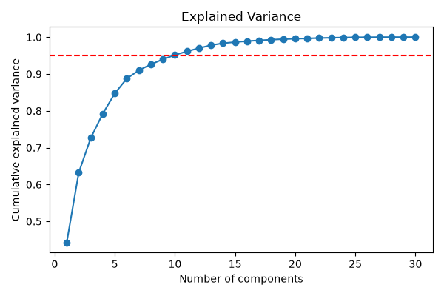
Figure 3.1: Cumulative explained variance (red line = 95%)
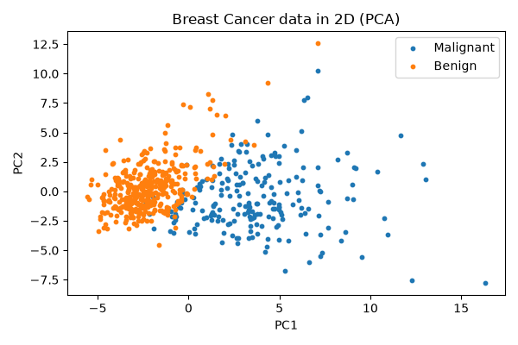
Figure 3.2: The 30-feature data shown in 2 dimensions

Observations
- PC1 explains 44.3% of the variance and PC2 another 19%. Two components hold 63.2% of what was in 30 columns.
- Keeping 95% of the variance takes 10 components, a third of the original count.
- In the 2D plot, malignant and benign samples form two fairly separate groups that overlap only a little in the middle.
- Logistic regression scored 0.979 on the full 30 features and also on the 2 components. We cut the columns 15 times over and lost no accuracy.

Conclusion
PCA brought the breast cancer data down from 30 features to 2. Some variance was lost, but the two classes were still clearly visible and the model's accuracy didn't change at all. For data with lots of columns, PCA is an easy way to make it smaller and quicker to work with, and to actually see it on a plot.

